Date: 10.14.2020

Version 1.0

**Author Document and Tool:** Idan Nachmani – email: [idan.nachmani@gmail.com](mailto:idan.nachmani@gmail.com)

**Basic Tool Control DNA with Rest API based on Python:**

The Idea of this tool is to easily configure DNA with Rest API based on a Python Code.

**There is a 5 simple Steps:**

* **Step1:** Modify the txt file “ip_address_pool.txt” that you can find in the general folder “Basic Tool Control DNA with Rest API based on Python”
* **Step2:** Pre-requisite step- provide – username / Password and the DNA IP Server
* **Step3:** Create a site by choose option 1, please provide the name for the site
* **Step4:** Adding Devices to the DNA Cluster, please provide your username and password.

Please Note that username/Password need to be applicable to all the devices that you want to add the cluster.

* **Step5:** Assign the Devices to the Site that you have created in Step3

**Step1:**Please modify the *.txt file - ip_address_pool.txt with the list of devices IP’s.

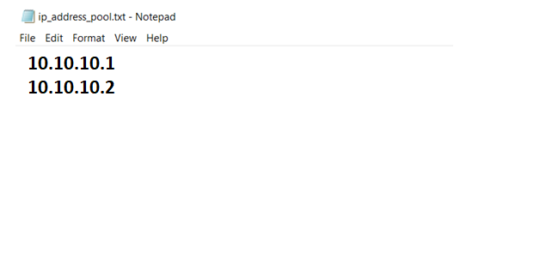

**Step2:**Please provide username, Password and Cluster IP.

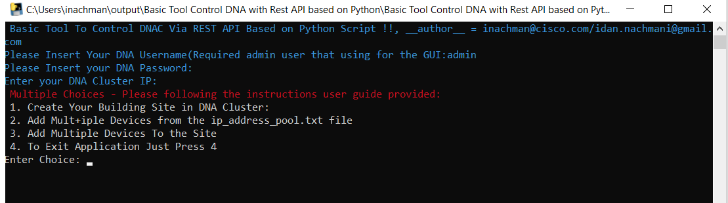

**Step3:**

Please Choose option 1, Provide a name for you site. For example: “Test_Idan”.

Once you enter then you will receive that site has been created.

Press enter for moving back to the “Multiple choices window”

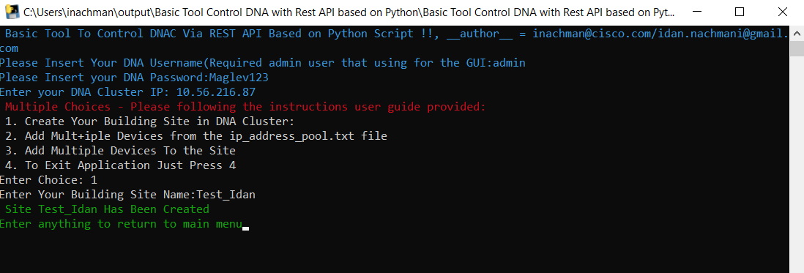

**Step4:**

Please Choose option 2, Please insert Username/Password and Enable password. **(Please note that in case that you don’t have the enable password since you are working with privilege 15 then you provide any password that will be skipped by the Script)**

Once you enter then the devices will be added and created in the DNAC Cluster.

Press enter for moving back to the “Multiple choices window”

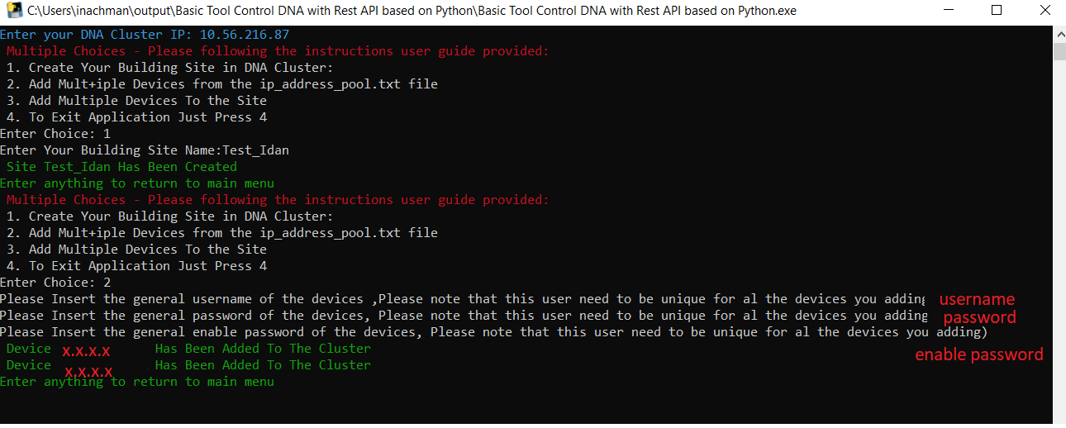

**Step4:**

Please Choose option 3,

Once you enter then the devices will be assigning to the site that you created in otion1.

Press enter for moving back to the “Multiple choices window”.

**Enjoy**